Research Methodology &
Seminar


Research Paper (2)

B.Tech. Semester VI Institute of Technology Nirma University

Prepared By
SARTH NAROLA (23BCE194) NEVIL ANGHAN (23BCE195)

Publication Details :

Title: Privacy Preservation in Diabetic Disease Prediction Using Federated Learning Based on Efficient Cross Stage Recurrent Model
Author Names: R. Jayalakshmi and T. Tamilvizhi
Author Affiliations: Department of Computer Science and Engineering, Panimalar Engineering College, Chennai, India
Country of Research: India
Published In: Scientific Reports
(Springer Nature)
Publication Year: 2025
Research Domain Category: Federated Learning, Privacy-Preserving AI, Medical Image Analysis, Diabetic Retinopathy Detection

Overview
Traditional deep learning methods for diabetic retinopathy (DR) detection require centralized data aggregation, which creates serious privacy and security concerns in healthcare. Federated learning (FL) solves data-sharing issues but suffers from high computational burden and reduced accuracy under heterogeneous data distributions.
Research Problem: How can a federated learning framework integrate secure encryption mechanisms and efficient client selection strategies to enhance diabetic retinopathy detection performance under heterogeneous and privacy-sensitive healthcare environments?

Research Gap : Existing FL-based DR detection models lack strong privacy mechanisms and efficient client selection strategies. Moreover, they struggle with non-IID data and communication overhead across distributed hospitals.

Background & Technical Concepts

• Proposed Model: FedDRNet (Federated Learning based Diabetic Retinopathy Detection Network)
• Core Architecture: Efficient Cross Stage Recurrent Network (ECSRNet)
• Backbone Components:
- ShuffleNet [Lightweight feature extraction]
- Cross Stage Partial Network (CSPNet) [Better feature representation & reduced memory]
- Gated Recurrent Unit (GRU) [Capture temporal disease patterns
• Privacy Mechanism: Homomorphic Encryption
• Client Selection: Improved K-Means Clustering (IKMC)
• Preprocessing: Multi-Scale Gaussian Bilateral Filtering (MSBF) [Remove noise, Preserve Edges]
• Aggregation: FedAvg

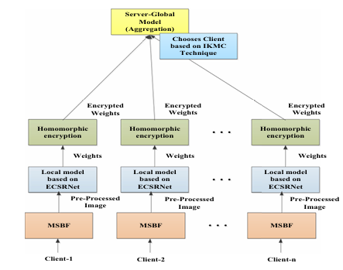

Key Mathematical Metrics

• Accuracy: 98.6%
• Precision: 98.8% (Reduces false positives)
• Recall: 98.3% (Detects more real DR cases)
• F1-Score: 98.6%
• Specificity: 98.1% (Correctly identifies healthy patients)

Statistical validation:
• Friedman Test Statistic: 16
• p-value: 0.003019 (statistically significant improvement

Datasets & Experimental Analysis
Datasets Used:
• Diabetic Retinopathy 2015 Data Colored Resized Dataset (35,126 images)
• Messidor Dataset (1,748 images)
Images resized to 224×224.
Experimental Setup:
• Total Clients: 10
• Communication Rounds: 60–90
• Optimizer: Adam
• Learning Rate: 1×10⁻⁴
• Training: 60%
• Validation: 20%
• Testing: 20%
Experimental Comparisons
Compared against:
• FLViT
• FedDL
• FedCNN
• DataWeightedFed
At 90 communication rounds:

Model | Accuracy
FLViT | 93.6%
FedDL | 94.9%
FedCNN | 96.8%
DataWeightedFed | 97.5%
FedDRNet | 98.6%

Challenges & Limitation

• Increased computational overhead due to Homomorphic Encryption.
• Limited handling of extreme non-IID distributions.
• Encryption adds communication latency.
• Model complexity higher than basic FedAvg approaches.

Results Conclusion

• Achieved state-of-the-art DR detection accuracy (98.6%).
• Homomorphic encryption ensures secure weight sharing.
• IKMC improves convergence speed and reduces communication rounds.
• ECSRNet provides lightweight yet powerful feature extraction.
• Demonstrated strong generalization across noise levels and datasets.

- Why to choose:
• Integrates strong privacy mechanism (Homomorphic Encryption).
• Addresses non-IID problem via clustering-based client selection.
• Provides detailed statistical validation (Friedman test).
• Evaluates computational cost, latency and convergence.

- Why should we not choose:
• Complex architecture may increase deployment difficulty.
• Encryption overhead increases training time.
• Uses FedAvg instead of advanced drift-correction methods like SCAFFOLD.
• Personalization layer not deeply explored.

- Tasks will be do:
• Integrate SCAFFOLD instead of only FedAvg.
• Combine Homomorphic Encryption with Differential Privacy.
• Introduce Personalized Federated Learning layer.
• Compare Secure Global vs Secure Personalized model.
• Evaluate Europe vs India cross-domain scenario explicitly.

